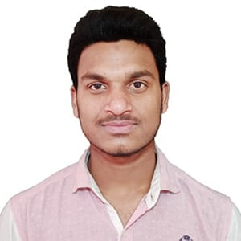**CV of MD: AL AMIN**

|  |  |  |
| --- | --- | --- |
| Name | : | AL AMIN |
| Father’s Name | : | MD. BAYRUL HAQUE |
| Mother’s Name | : | Most. RAKHA BEGUM |
| Date Of Birth | : | 17/10/2002 |
| Nationality | : | BANGLADESHI |
| Religion | : | ISLAM |
| Marital Status | : | SINGLE |
| Gender | : | MALE |
| Mobile Number | : | 01701741968 |
| Email | : | mdalaminmoyen@gmail.com |
| Present Address |  | VILLAGE: CHARPANKA, POST OFFICE: BABUPUR), UPAZILA: SHIBGONJ, DISTRICT: CHAPAINABABGANJ. |
| Permanent Address |  | HALL: SHAHID MUKHTHER ELAHI HALL, BRUR, POST OFFICE: CADET COLLEGE (5400), UPAZILA: RANGPUR SADAR, DISTRICT: RANGPUR. |

**Educational Information:**

|  |  |  |  |  |  |
| --- | --- | --- | --- | --- | --- |
| Examination | Board/University | Result | Group / Subject | Year | Duration |
| S.S.C | Rajshahi | 4.11 | Humanities | 2018 | N/A |
| H.S.C | Rajshahi | 4.17 | Humanities | 2020 | N/A |

**EXPERIENCE:**

* MICROSOFT WORD
* MICROSOFT EXCEL
* MICROSOFT POWERPOINT
* CONTENT WRITING
* CONTENT CREATE

**EXTRA-CURRICULLAR ACTIVITIES:**

* LEADERSHIP
* PLAYING CRICKET
* SWIMMING
* PLAYING BADMINTON